KSA Reflection

KSA J—the functions of traditional and electronic teaching/learning technologies. They know how to use and how to engage students in using these technologies to present and deliver content, communicate effectively with others, find and secure information, research, word process, manage information, and keep records.

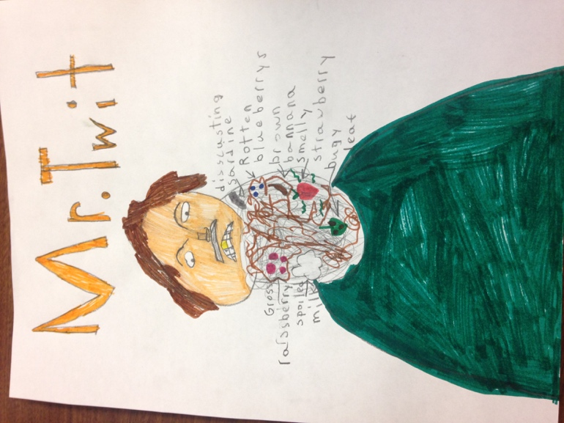
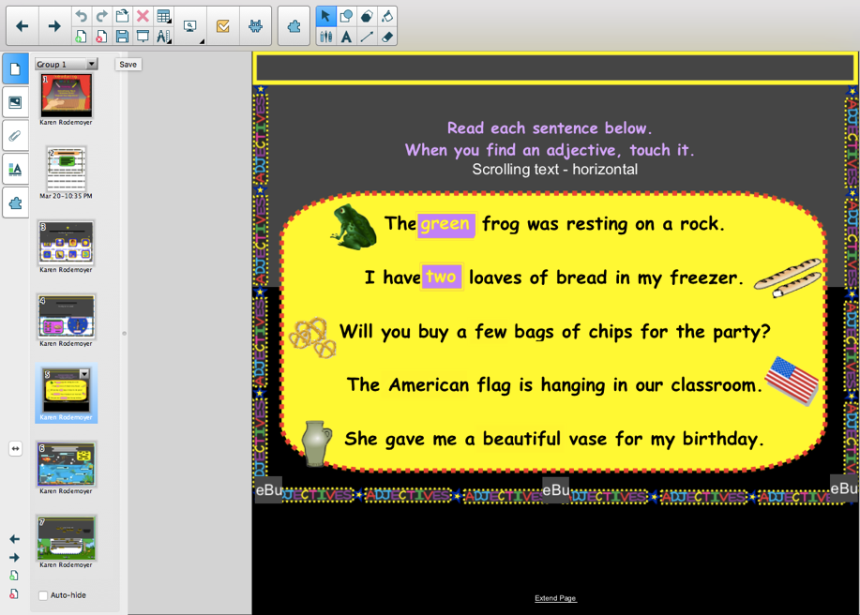
My knowledge of how to use and how to engage students in using traditional and electronic technologies to present and deliver content and communicate effectively with others is demonstrated through my Smart Board activities. I was covering the grade 3 English Language Arts specific outcome 4.2—use adjectives and adverbs to add interest and detail to own writing in my novel study. The end goal was to have the students create a portrait of the main character in our novel study, Mr. Twit and label the drawing using adjectives. The students were having troubles remembering the difference between adjectives and nouns, so I engaged the students with a Smart Board activity that involved picking out the adjectives. The technology sparked interest with the students, and the level of engagement increased. With the rise in engagement, I was able to effectively communicate the difference between nouns and adjectives. The students were then able to complete their portrait of Mr. Twit with the use of effective adjectives to describe his beard.
Left: Image of the Smart Board activity I used to engage students with adjectives.
Right: Portrait of Mr. Twit with labelled food using adjectives to describe them.

