KSA Reflection One

KSA E—all students can learn, albeit at different rates and in different ways. They know how (including when and how to engage others) to identify students’ different learning styles and ways students learn. They understand the need to respond to differences by creating multiple paths to learning for individuals and groups of students, including students with special learning needs;

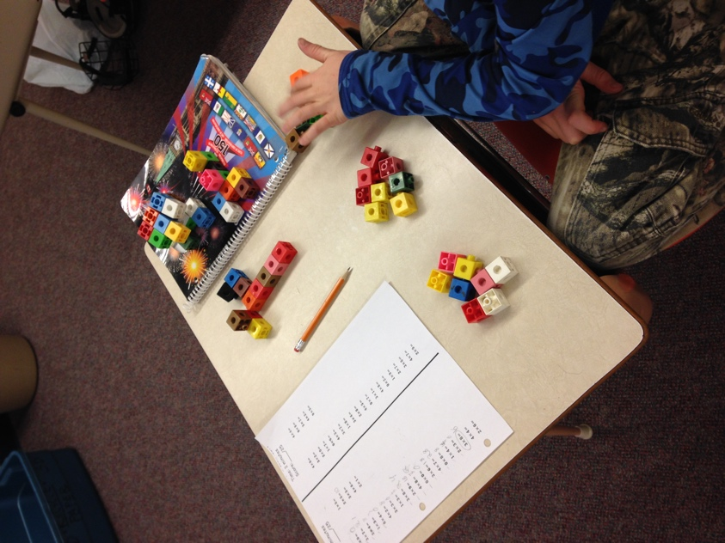
My knowledge that students learn at different rates and in different ways was demonstrated through adapting a concept to a student’s interest to increase their engagement. This student was having attention difficulties during the individual multiplication practice time. I noticed that the student was off task because they were not completing many questions on their worksheet. Instead, the student was spending their time making robots out of the counting blocks that were provided to aid their understanding with multiplying. I approached the situation with the thought of “how will I get this student more engaged?”. I decided to create a new pathway of learning for this particular student, because I understand that students learn in different ways. The pathway that I created unified the student’s interest and the task at hand. I had the student build me a robot that had the same amount of blocks as the product of the multiplication question. The student would build a robot of $4×3$, therefore, the student would have to find the product first and then build the robot. The robot building worked wonders for this particular student, they were so engaged in wanting to build a robot, they would quickly complete the multiplication question so they could make a robot. I made a deal that once they completed five questions, on the sixth question they were to create a robot that had the same amount of blocks as the questions product. The student zoomed through the questions with a smile on their face!
Above is the artifact that demonstrates the math robot building. The robots can be seen on the student’s agenda, top right corner of the picture. The photo shows the student figuring out the product to $3×8$ so that they know how many blocks they can use to create their robot.

