KSA Reflection
KSA M—You understand that student learning is enhanced by using home and community resources. You know how to identify resources relevant to teaching and learning objectives and how to incorporate these resources into your teaching and into students’ learning;

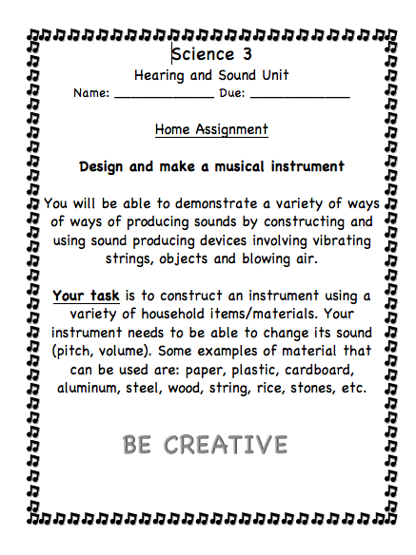
I have demonstrated my understanding of the importance that student learning is enhanced by using home and community resources through my make your own instrument assignment. Their make your own instrument was an assignment that was sent home with them over the week off. They were instructed to create an instrument using at home materials. I let the students know that it was acceptable and encouraged to invite their parents, grandparents, siblings, etc., to help them create their instrument. I sent an email, and a letter home in the students’ agendas regarding the project. The adults in the students lives knew about the project and took part in helping the students create their instrument. Incorporating home and community resources into the students’ learning helped with engagement and furthered the students’ understandings regarding hearing and sound.

