KSA Reflection

KSA K—The purposes of student assessment. They know how to assess the range of learning objectives by selecting and developing a variety of classroom and large scale assessment techniques and instruments. They know how to analyze the results of classroom and large scale assessment instruments including provincial assessment instruments, and how to use the results for the ultimate benefit of students;

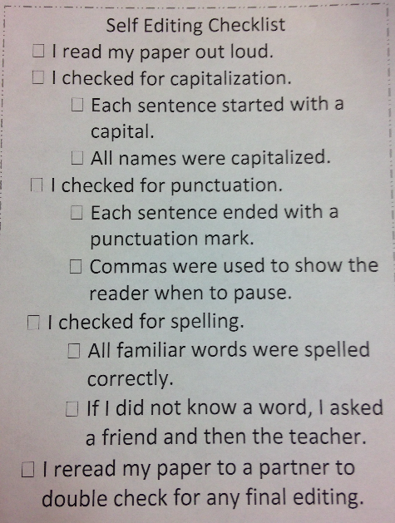
I have demonstrated my knowledge of KSA K through a variety of student assessment practices. I have shown that I am capable of assessing a range of learning objectives by selecting and developing a variety of classroom assessment techniques. I have implemented many different types of assessments within the grade 3 class. We have done visual learning pages, clay models, experiments, create your own instrument, draw me a picture, show me with your body, self assessment and much more. See below for some images of what we have done in class to demonstrate student learning.

