KSA Reflection
KSA I—There are many approaches to teaching and learning. They know a broad range of instructional strategies appropriate to their area of specialization and the subject discipline they teach, and know which strategies are appropriate to help different students achieve different outcomes;

I have demonstrated my understanding of KSA I through implementing different types of instructional strategies through my final internship at A.B. Daley. I wanted the students to have experience to a broad range of instructional strategies in order to achieve different outcomes. A few examples I used were, technology games, discovery, experiments, different areas around the school, artifacts and much more. The students enjoyed learning about different topics through different strategies. It kept them engaged and interested in what we were learning.
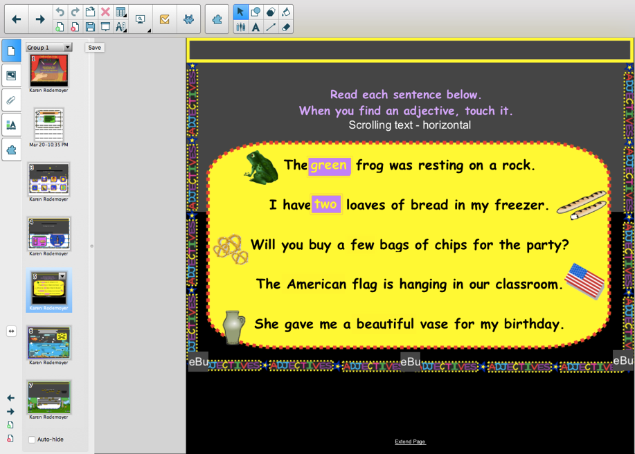
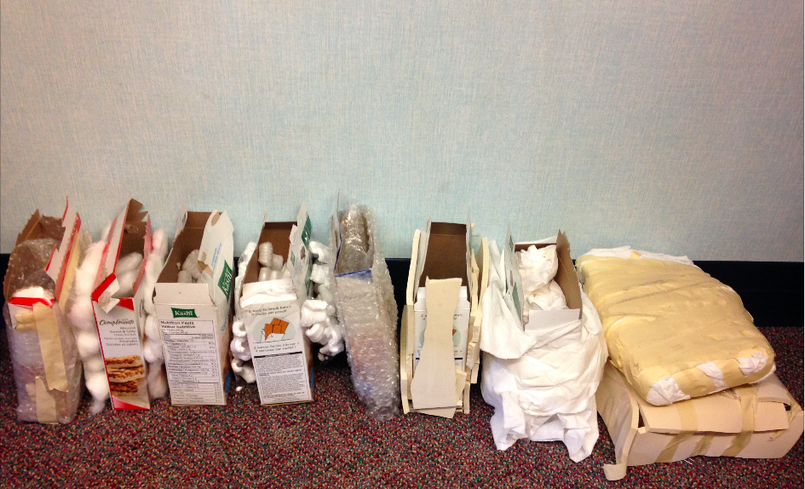
Experiment—Sound Proofing Boxes
Smart Board—Technology Game

