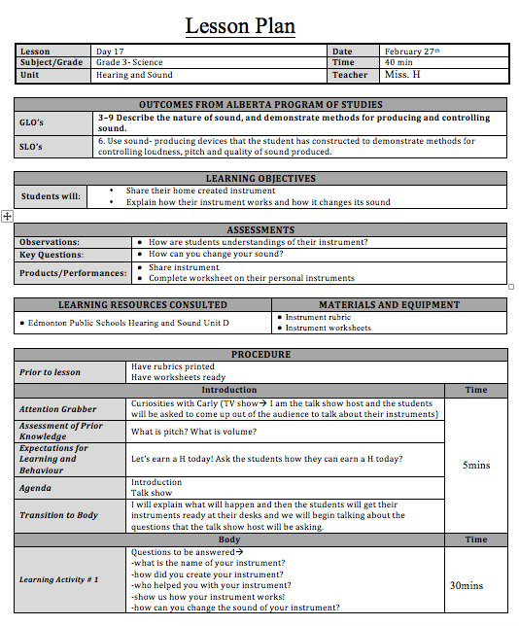
KSA Reflection
KSA F—The purposes of short, medium and long term range planning. They know how to translate curriculum and desired outcomes into reasoned, meaningful and incrementally progressive learning opportunities for students. They also understand the need to vary their plans to accommodate individuals and groups of students;

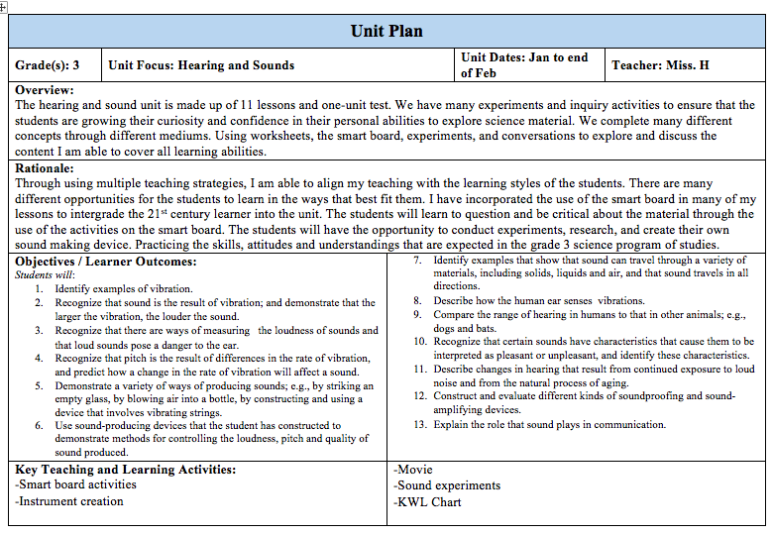
I have demonstrated knowledge of KSA F through my extensive planning through PS1, PS2, and PS3. Within my final internship I took on long term planning, unit planning, and lesson planning. I have developed the skills to create desired outcomes into reasoned, meaningful and incrementally progressive learning opportunities for students.

