KSA Reflection

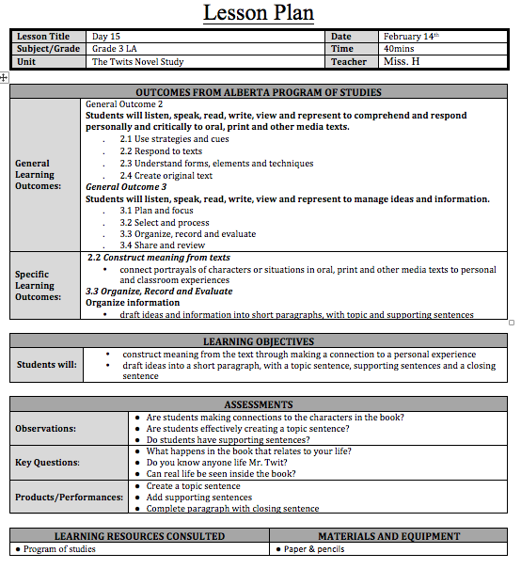
KSA D—The subject disciplines they teach. They have completed a structured program of studies through which they acquired the knowledge, concepts, methodologies and assumptions in one or more areas of specialization or subject disciplines taught in Alberta schools;

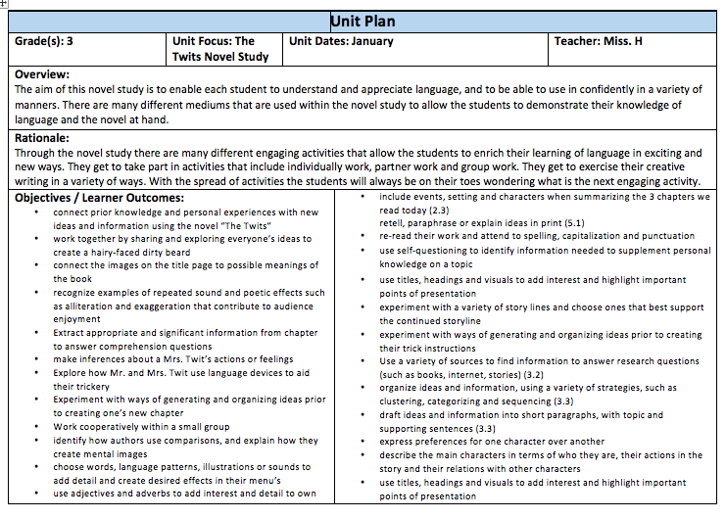
I demonstrated my knowledge of KSA D through my long range planning, unit planning and lesson planning for all subjects that I teach. My understandings of the knowledge, concepts, methodologies and assumptions in subject disciplines has been shown through my planning in all subjects that I teach. I have taught, English language arts, science, social studies, physical education, and art. All of these subject disciplines I have acquired the knowledge, concepts, methodologies and assumptions of those subject areas.

