KSA Reflection
The importance of guiding their actions with a personal, overall vision of the purpose of teaching. They are able to communicate their vision, including how it has changed as a result of new knowledge, understanding and experience;

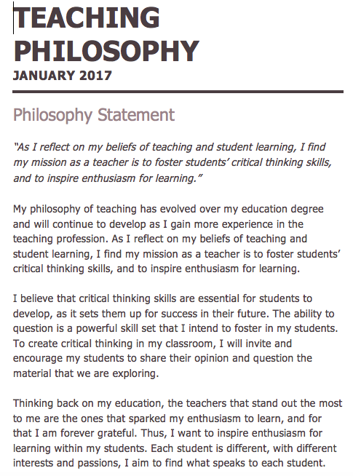
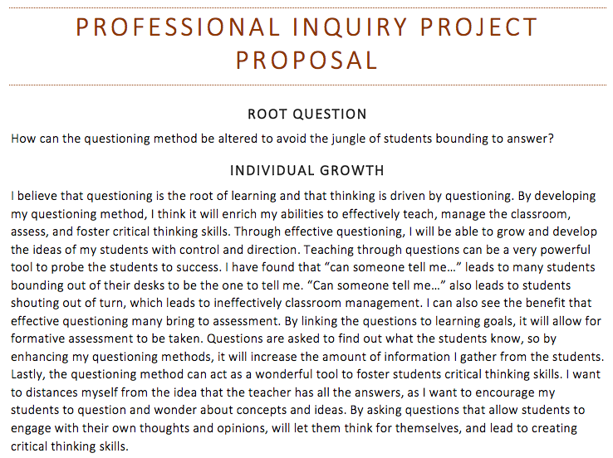
My mission in teaching has grown and changed over my time in school. I have revisited my teaching philosophy again this year and made changes to where I see fit. I understand the importance that my actions reflect my personal vision of teaching and learning. I demonstrate my knowledge of KSA P through the development and application of my teaching philosophy. As I reflect on my beliefs of teaching and student learning, I find my mission as a teacher is to foster students’ critical thinking skills, and to inspire enthusiasm for learning. I have always had a vision of challenging students to think and question ideas and concepts brought up in class, but I wanted to find different and better ways to conduct questioning in my class. Within my professional inquiry project, I am searching for ways to better my questioning methods to enhance my students learning and engagement within the class, furthermore, I hope to inspire enthusiasm for learning.

