KSA Reflection
KSA C—the purposes of the Guide to Education and programs of study germane to the specialization or subject disciplines they are prepared to teach. They know how to use these documents to inform and direct their planning, instruction and assessment of student progress;

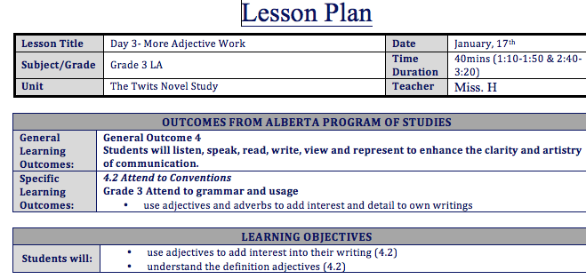
I have demonstrated knowledge of KSA C through my planning, teaching and assessing. I start my planning with reading and choosing general (GLO) and specific (SLO) learning outcomes from the respective programs of study. Using the GLO’s and SLO’s, I create my assessments for the unit and the rubric’s that will be used. Within my lesson plans, I create learning objectives for the students based on the learning outcomes that will be assessed. Evidence that demonstrates my understanding of KSA C is shown within my Mr. Twit novel study. Planning for this unit I have shown that I understand the purpose of the Guide to Education and the programs of study for English Language Arts. I have created assessments, lessons and instruction that correlate directly to the outcomes listed within the program of study. The students are aware of what they are learning, and the purpose of the activities that I conduct in class.
Lesson plan for beard activity and learning about adjectives
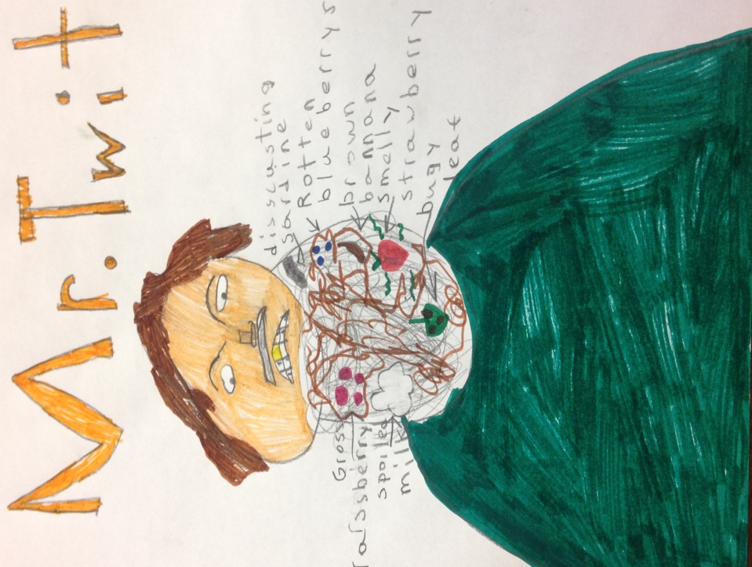
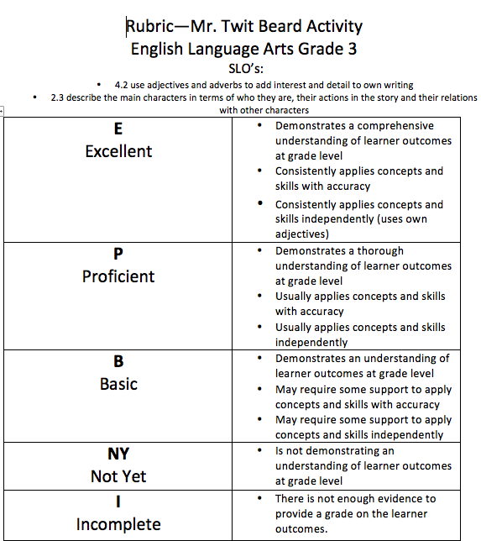
Mr. Twit beard example
Rubric for adjectives that describe Mr. Twit’s beard

