Where am I from?
I am
From long views and Longview
From paradise between Rocky Mountains and rolling hills
From lush lands cloaked with hay bales
I am
From country bumkins that pitch
“A little bit of dirt before you die”
“Dance like no one’s watching”
and “I love you to the moon and back”
I am
From short but countless canoe rides to home sweet home
From the piercing crackle that rises from the wood stove
From rich violet crocuses springing to bring spring
I am
From eight second rides to glory and fame
From the jingling rowels of Texas spurs
I am
From fighters and believers
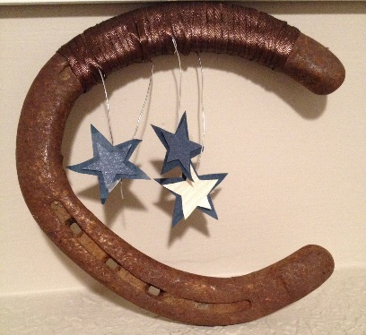
From lullabies that told the truth
From cords that sang me to sleep

I was born under a wanderin’ star

